Neighbor Joining-based rooted phylogenetic trees
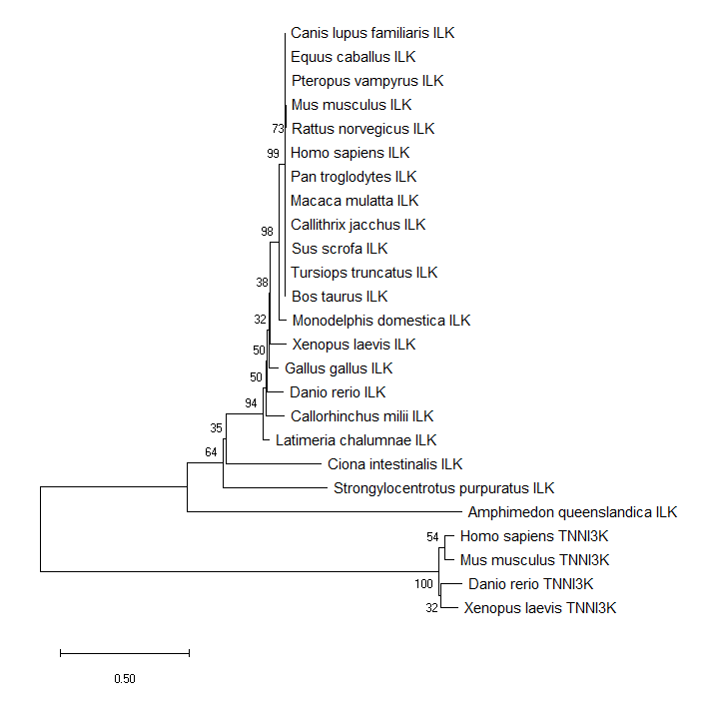
Fig. 1. Neighbor-Joining-based rooted phylogenetic tree of the protein sequences encoded by the ILK genes. TNNI3K is used as outgroup. The branch length represents evolutionary distance. A discrete Gamma distribution was used to model evolutionary rate differences among sites. The scale bar at the lower left denoted the length of amino acid substitutions per site.
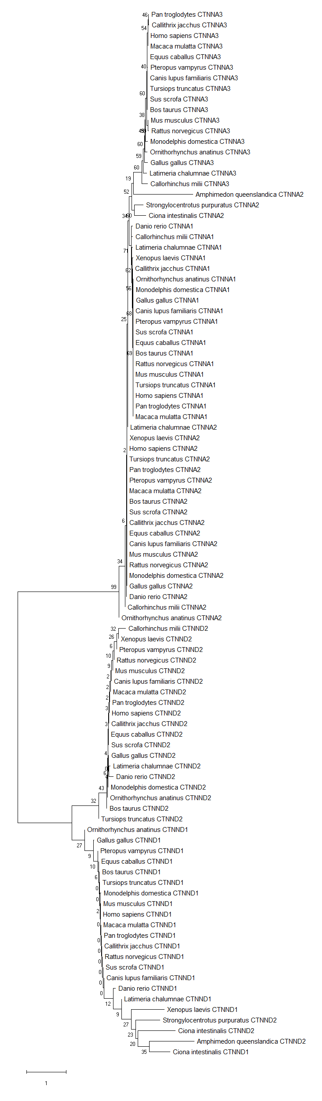
Fig. 2. Neighbor-Joining-based unrooted phylogenetic tree of the protein sequences encoded by the CTNNA1, CTNNA2, CTNNA3, CTNND1 and CTNND2 genes. The conventions are the same as in Fig. 1.
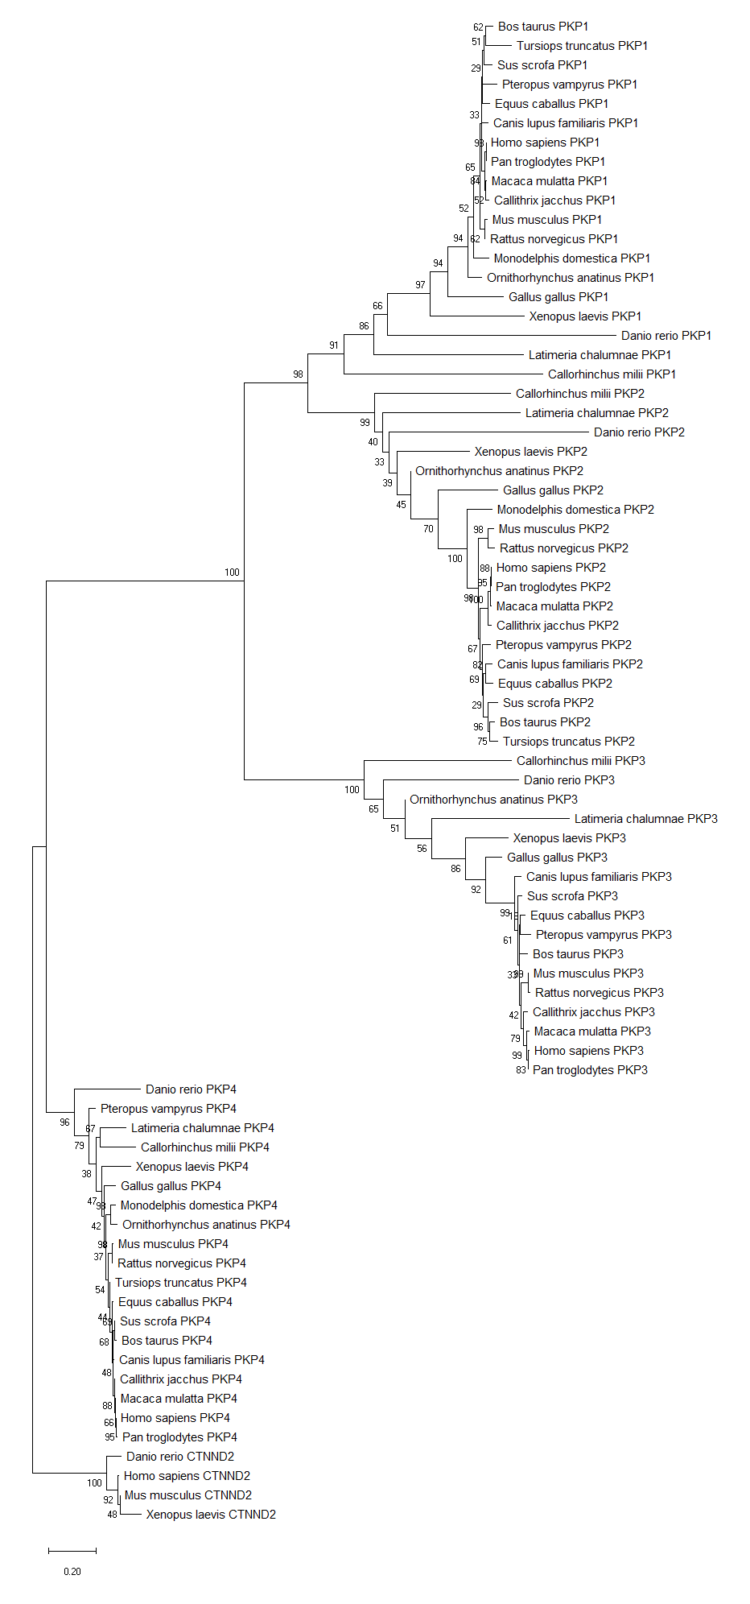
Fig. 3. Neighbor-Joining-based rooted phylogenetic tree of the protein sequences encoded by the PKP1, PKP2, PKP3 and PKP4 genes. CTNND2 is used as outgroup. The conventions are the same as in Fig. 1.

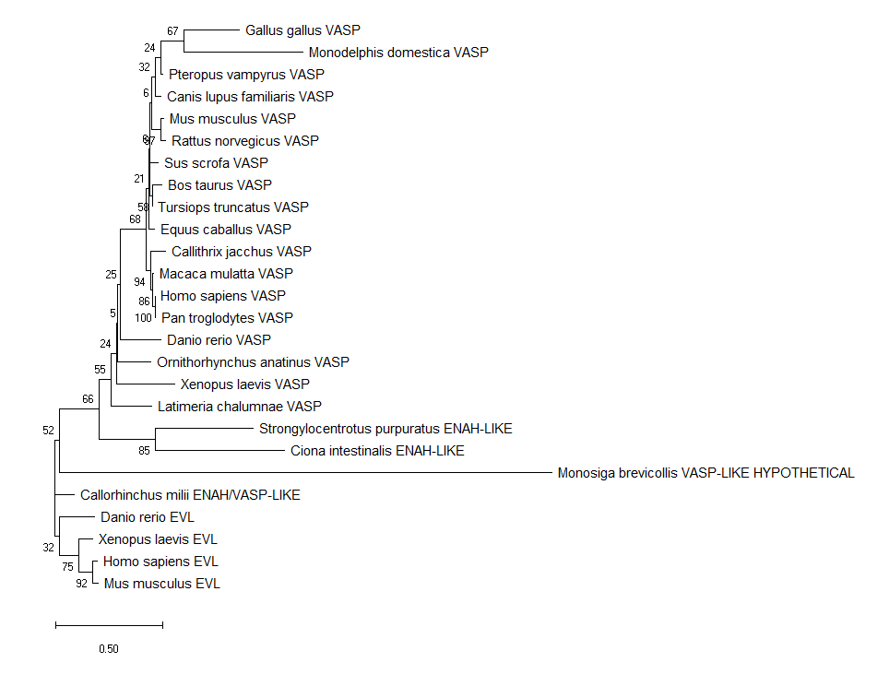

Fig. 4. Neighbor-Joining-based rooted phylogenetic tree of the protein sequences encoded by the VASP and ENAH-LIKE / ENAH/VASP-LIKE genes. EVL is used as outgroup. The conventions are the same as in Fig. 1.

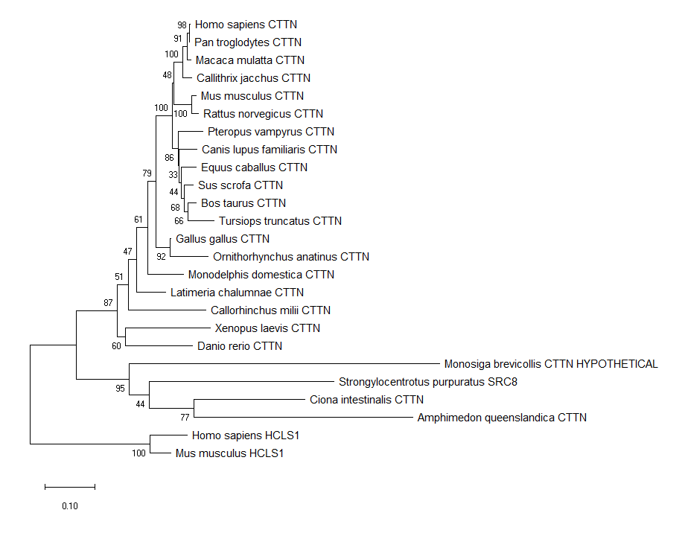
Fig. 5. Neighbor-Joining-based rooted phylogenetic tree of the protein sequences encoded by the CTTN genes. HCLS1 is used as outgroup. The conventions are the same as in Fig. 1

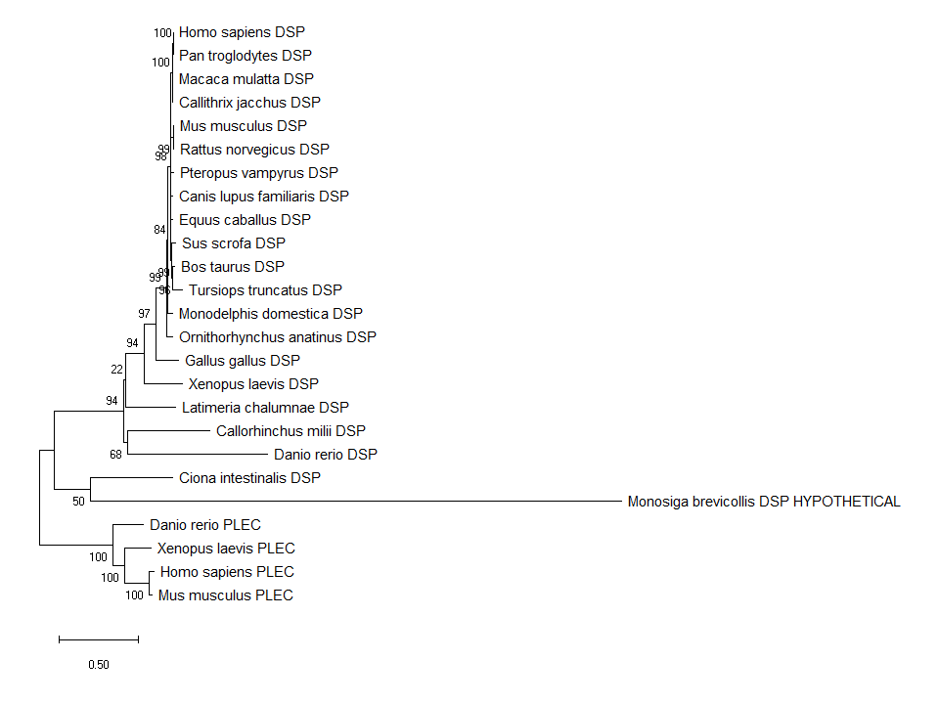
Fig. 6. Neighbor-Joining-based rooted phylogenetic tree of the protein sequences encoded by the DSP genes. PLEC is used as outgroup. The conventions are the same as in Fig. 1.

Fig. 7. Neighbor-Joining-based rooted phylogenetic tree of the protein sequences encoded by the PLEC genes. MAKF1 is used as outgroup. The conventions are the same as in Fig. 1.

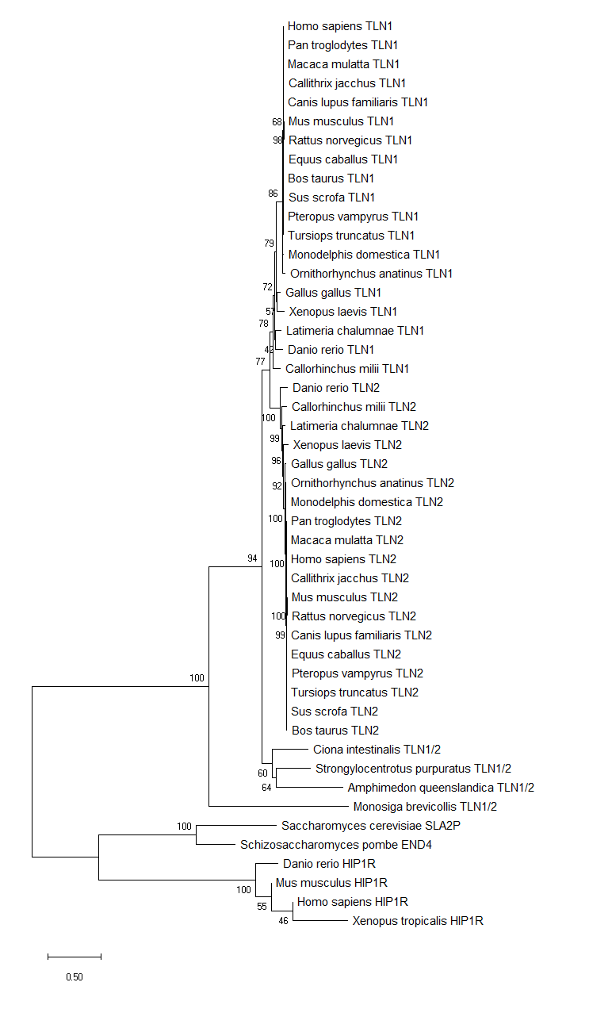
Fig. 8. Neighbor-Joining-based rooted phylogenetic tree of the protein sequences encoded by the TLN1 and TLN2 genes. HIP1R is used as outgroup. The conventions are the same as in Fig. 1.
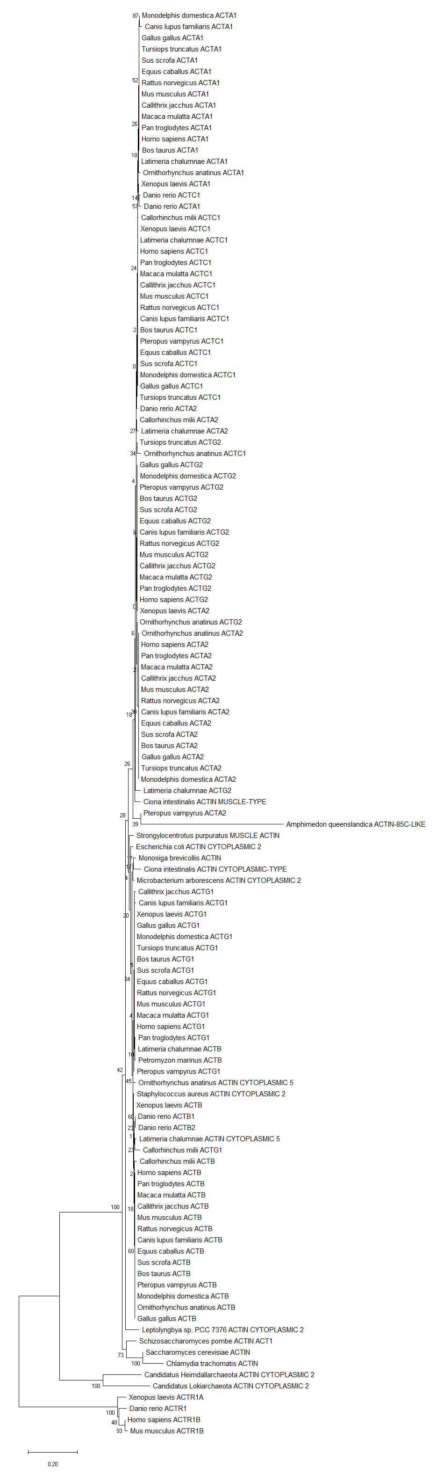
Fig. 9. Neighbor-Joining-based rooted phylogenetic tree of the protein sequences encoded by the ACTA1, ACTA2, ACTB, ACTC1, ACTG1 and ACTG2 genes. ACTR1, ACTR1A and ACTRB are used as outgroup. The conventions are the same as in Fig. 1.
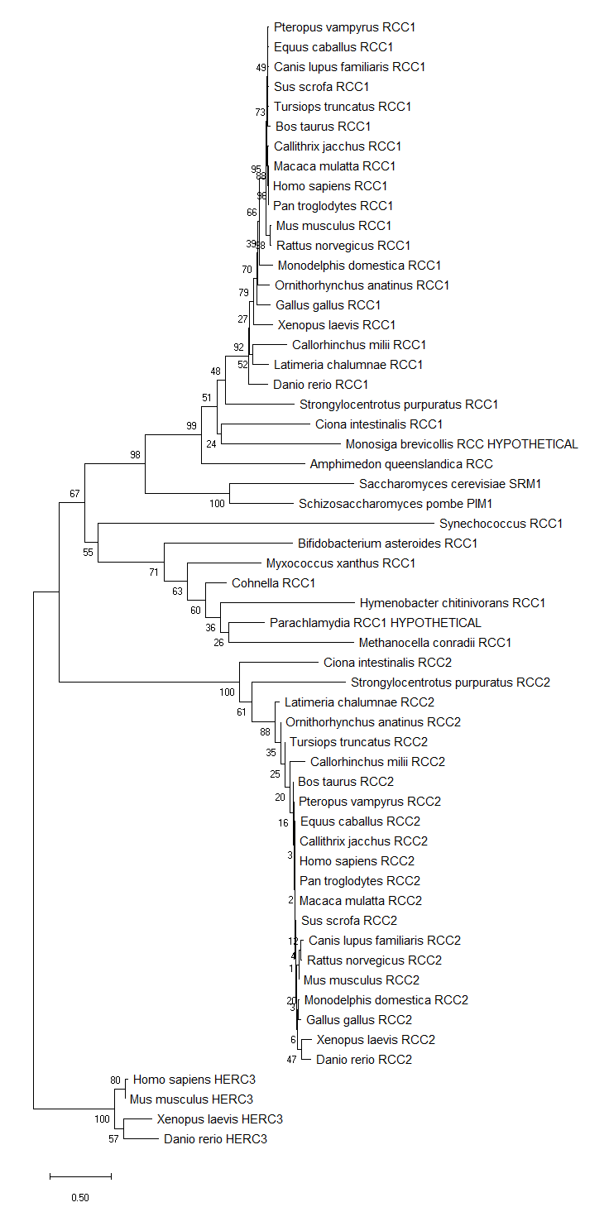
Fig. 10. Neighbor-Joining-based rooted phylogenetic tree of the protein sequences encoded by the RCC1 and RCC2 genes. HERC3 is used as outgroup. The conventions are the same as in Fig. 1.

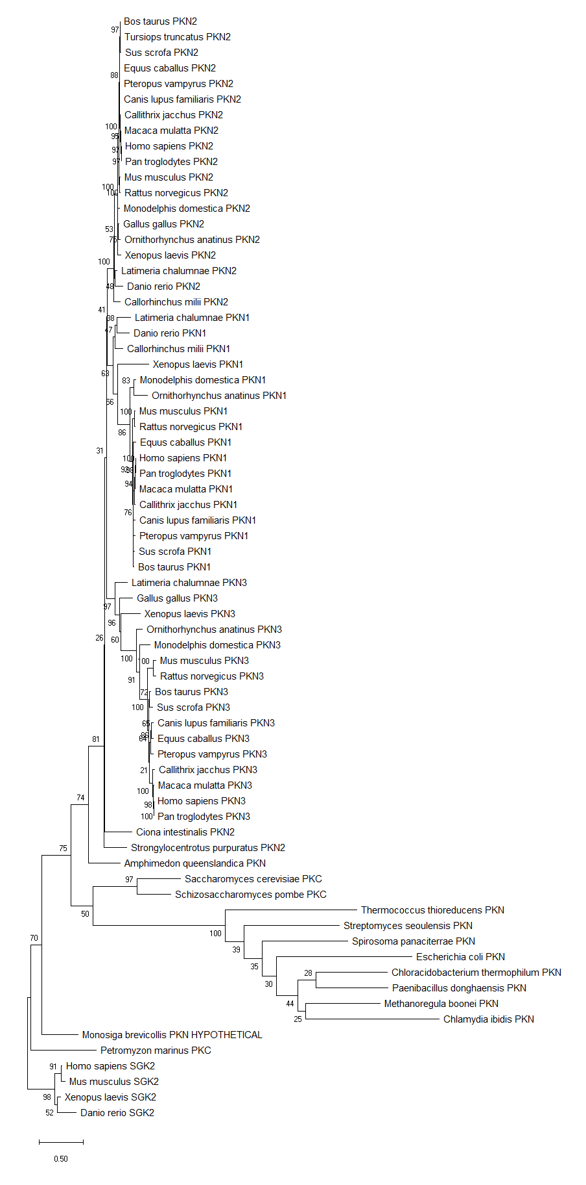
Fig. 11. Neighbor-Joining-based rooted phylogenetic tree of the protein sequences encoded by the PKN1, PKN2, PKN3, PKN, PKC genes. SGK2 is used as outgroup. The conventions are the same as in Fig. 1.

